Graph :
a graph is an ordered pair G = (V, E)
point :
A point is a particular position that is located in a space. Space can be one-dimensional, two- dimensional or three-dimensional space. A dot is used to represent a point in graph and it is labeled by alphabet, numbers or alphanumeric values.
Line :
Two points are connected to each other through a line. A line is a connection between two points. It is represented by a solid line.
Vertex :
A vertex is a synonym of point in graph i.e. one of the points on which the graph is defined and which may be connected by lines/edges is called a vertex. Vertex is also called "node", "point" or "junction". A vertex is denoted by alphabets, numbers or alphanumeric value.
Edge is the connection between two vertices.

Types of Graph :

NULL Graph :
A null graph is a graph in which there are no edges between its vertices. A null graph is also called empty graph.

A trivial graph is the graph which has only one vertex.

A simple graph is the undirected graph with no parallel edges and no loops

An undirected graph is a graph whose edges are not directed.
A directed graph is a graph in which the edges are directed by arrows.
Complete Graph
A graph in which every pair of vertices is joined by exactly one edge is called complete graph. It contains all possible edges.
A complete graph with n vertices contains exactly nC2 edges and is represented by Kn.

In computer network, the relationships among interconnected computers within the network, follow the principles of graph theory.
- Graph theory is also used in network security.
- We can use the vertex coloring algorithm to find a proper coloring of the map with four colors.
- Vertex coloring algorithm may be used for assigning at most four different frequencies for any GSM (Grouped Special Mobile) mobile phone networks.

For 0/1 knapsack
T(i,j)=max{(t(i-1,j),v[i]+t(i-1,j-w[i])}

MultiThreading
It is a process to executing multiple threads simultaneously
A thread is a lightweight sub-process, the smallest unit of processing.
Multithreading and Multiprocessing are used to achive multitasking

Multithreading means that you have multiple threads of execution inside the same application. A thread is like a separate CPU executing your application. Thus, a multithreaded application is like an application that has multiple CPUs executing different parts of the code at the same time.
A thread is not equal to a CPU though. Usually a single CPU will share its execution time among multiple threads, switching between executing each of the threads for a given amount of time. It is also possible to have the threads of an application be executed by different CPUs.

Advantages of Java Multithreading
1) It doesn't block the user because threads are independent and you can perform multiple operations at the same time.
2) You can perform many operations together, so it saves time.
3) Threads are independent, so it doesn't affect other threads if an exception occurs in a single thread.

MultiTasking :
Multitasking is a process of executing multiple tasks simultaneously. We use multitasking to utilize the CPU.

Multitasking can be achieved in two ways:
Process-based Multitasking (Multiprocessing)
Thread-based Multitasking (Multithreading)

Process-based Multitasking (Multiprocessing) :
Each process has an address in memory. In other words, each process allocates a separate memory area.
A process is heavyweight.
Cost of communication between the process is high.
Switching from one process to another requires some time for saving and loading registers, memory maps, updating lists, etc.

Thread-based Multitasking (Multithreading)
Threads share the same address space.
A thread is lightweight.
Cost of communication between the thread is low.

At least one process is required for each thread.

There are several reasons as to why one would use multithreading in an application. Some of the most common reasons for multithreading are:
Better utilization of a single CPU.
Better utilization of multiple CPUs or CPU cores.
Better user experience with regards to responsiveness.
Better user experience with regards to fairness.
Benfits :

Better CPU Utilization

Simpler Program Design

More Responsive Programs

More Fair Distribution of CPU Resources
Life cycle of a Thread (Thread States)
In Java, a thread always exists in any one of the following states. These states are:
- New - Whenever a new thread is created, it is always in the new state. For a thread in the new state, the code has not been run yet and thus has not begun its execution.
- Active : When a thread invokes the start() method, it moves from the new state to the active state. The active state contains two states within it: one is runnable, and the other is running.
  - Runnable : thread, that is ready to run is then moved to the runnable state. In the runnable state, the thread may be running or may be ready to run at any given instant of time. It is the duty of the thread scheduler to provide the thread time to run, i.e., moving the thread the running state.
  - Running : When the thread gets the CPU, it moves from the runnable to the running state. Generally, the most common change in the state of a thread is from runnable to running and again back to runnable.
- Blocked / Waiting : Whenever a thread is inactive for a span of time (not permanently) then, either the thread is in the blocked state or is in the waiting state.
- Timed Waiting : Sometimes, waiting for leads to starvation. To avoid such scenario, a timed waiting state is given to thread B. Thus, thread lies in the waiting state for a specific span of time, and not forever. A real example of timed waiting is when we invoke the sleep() method on a specific thread. The sleep() method puts the thread in the timed wait state. After the time runs out, the thread wakes up and start its execution from when it has left earlier.
- Terminated : A thread reaches the termination state because of the following reasons:
  - When a thread has finished its job, then it exists or terminates normally.
  - Abnormal termination: It occurs when some unusual events such as an unhandled exception or segmentation fault.
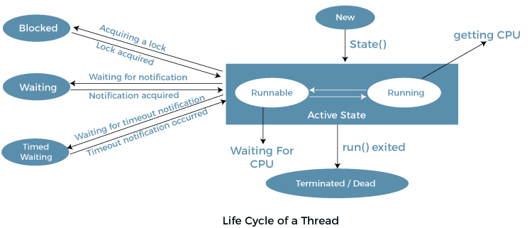

two ways to create a thread:
- By extending Thread class
- By implementing Runnable interface.

By Extending Thread Class :
Thread class provide constructors and methods to create and perform operations on a thread.Thread class extends Object class and implements Runnable interface.

Commonly used Constructors of Thread class:
Thread()
Thread(String name)
Thread(Runnable r)
Thread(Runnable r,String name)
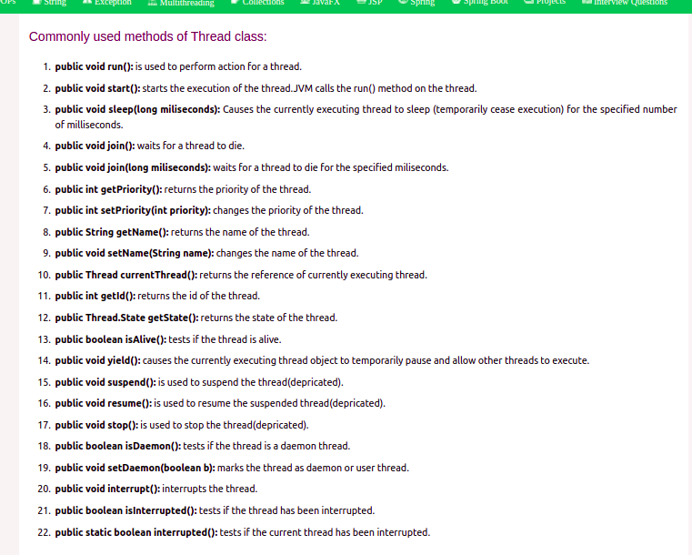

Runnable interface:
The Runnable interface should be implemented by any class whose instances are intended to be executed by a thread. Runnable interface have only one method named run().
- public void run(): is used to perform action for a thread.
Starting a thread:
The start() method of Thread class is used to start a newly created thread. It performs the following tasks:
- A new thread starts(with new callstack).
- The thread moves from New state to the Runnable state.
- When the thread gets a chance to execute, its target run() method will run.

Thread Scheduler :
A component of Java that decides which thread to run or execute and which thread to wait is called a thread scheduler in Java
a thread is only chosen by a thread scheduler if it is in the runnable state. However, if there is more than one thread in the runnable state, it is up to the thread scheduler to pick one of the threads and ignore the other ones. There are some criteria that decide which thread will execute first. There are two factors for scheduling a thread i.e. Priority and Time of arrival.
Priority: Priority of each thread lies between 1 to 10. If a thread has a higher priority, it means that thread has got a better chance of getting picked up by the thread scheduler.
Time of Arrival: Suppose two threads of the same priority enter the runnable state, then priority cannot be the factor to pick a thread from these two threads. In such a case, arrival time of thread is considered by the thread scheduler. A thread that arrived first gets the preference over the other threads.

Thread Scheduler Algorithms:

First Come First Serve Scheduling:
In this scheduling algorithm, the scheduler picks the threads thar arrive first in the runnable queue.

Time-slicing scheduling:
the First Come First Serve algorithm is non-preemptive, which is bad as it may lead to infinite blocking (also known as starvation). To avoid that, some time-slices are provided to the threads so that after some time, the running thread has to give up the CPU. Thus, the other waiting threads also get time to run their job.

Preemptive-Priority Scheduling:
Preemptive Priority Scheduling, at the time of arrival of a process in the ready queue, its Priority is compared with the priority of the other processes present in the ready queue as well as with the one which is being executed by the CPU at that point of time. The One with the highest priority among all the available processes will be given the CPU next.
The difference between preemptive priority scheduling and non preemptive priority scheduling is that, in the preemptive priority scheduling, the job which is being executed can be stopped at the arrival of a higher priority job.
Once all the jobs get available in the ready queue, the algorithm will behave as non-preemptive priority scheduling, which means the job scheduled will run till the completion and no preemption will be done.
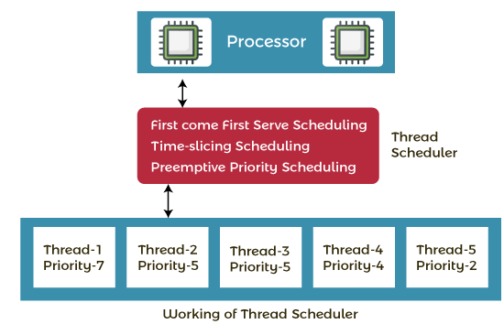

Thread.sleep() :
Thread class provides the two variant of the sleep() method. First one accepts only an arguments, whereas the other variant accepts two arguments.
public static void sleep(long mls) throws InterruptedException
public static void sleep(long mls, int n) throws InterruptedException
mls: The time in milliseconds is represented by the parameter mls. The duration for which the thread will sleep is given by the method sleep().
n: It shows the additional time up to which the programmer or developer wants the thread to be in the sleeping state. The range of n is from 0 to 999999.
The method does not return anything.

Whenever the Thread.sleep() methods execute, it always halts the execution of the current thread.
Whenever another thread does interruption while the current thread is already in the sleep mode, then the InterruptedException is thrown.
If the system that is executing the threads is busy, then the actual sleeping time of the thread is generally more as compared to the time passed in arguments. However, if the system executing the sleep() method has less load, then the actual sleeping time of the thread is almost equal to the time passed in the argument.

Can we start a thread twice?
No. After starting a thread, it can never be started again. If we do this so, an IllegalThreadStateException is thrown. In such case, thread will run once but for second time, it will throw exception

if we direct call run() method no context-switching because here t1 and t2 will be treated as normal object not thread object
Each thread starts in a separate call stack.
Invoking the run() method from the main thread, the run() method goes onto the current call stack rather than at the beginning of a new call stack.

JOIN Method
The join() method in Java is provided by the java.lang.Thread class that permits one thread to wait until the other thread to finish its execution
join():When the join() method is invoked, the current thread stops its execution and the thread goes into the wait state. The current thread remains in the wait state until the thread on which the join() method is invoked has achieved its dead state. If interruption of the thread occurs, then it throws the InterruptedException.
public final void join() throws InterruptedException

join(long mls): When the join() method is invoked, the current thread stops its execution and the thread goes into the wait state. The current thread remains in the wait state until the thread on which the join() method is invoked called is dead or the wait for the specified time frame(in milliseconds) is over.
public final synchronized void join(long mls) throws InterruptedException,where mls is in milliseconds

join(long mls, int nanos): When the join() method is invoked, the current thread stops its execution and go into the wait state. The current thread remains in the wait state until the thread on which the join() method is invoked called is dead or the wait for the specified time frame(in milliseconds + nanos) is over.
Syntax:
public final synchronized void join(long mls, int nanos) throws InterruptedException, where mls is in milliseconds.

Priority :
Each thread has a priority. Priorities are represented by a number between 1 and 10. In most cases, the thread scheduler schedules the threads according to their priority (known as preemptive scheduling). But it is not guaranteed because it depends on JVM specification that which scheduling it chooses. Note that not only JVM a Java programmer can also assign the priorities of a thread explicitly in a Java program.
public final int getPriority(): The java.lang.Thread.getPriority() method returns the priority of the given thread.
public final void setPriority(int newPriority): The java.lang.Thread.setPriority() method updates or assign the priority of the thread to newPriority. The method throws IllegalArgumentException if the value newPriority goes out of the range, which is 1 (minimum) to 10 (maximum).

3 constants defined in Thread class:
- public static int MIN_PRIORITY
- public static int NORM_PRIORITY
- public static int MAX_PRIORITY
Default priority of a thread is 5 (NORM_PRIORITY). The value of MIN_PRIORITY is 1 and the value of MAX_PRIORITY is 10.

Daemon thread in Java
it is a service provider thread that provides services to the user thread. Its life depend on the mercy of user threads i.e. when all the user threads dies, JVM terminates this thread automatically.
There are many java daemon threads running automatically e.g. gc, finalizer etc.
You can see all the detail by typing the jconsole in the command prompt. The jconsole tool provides information about the loaded classes, memory usage, running threads etc.
- It provides services to user threads for background supporting tasks. It has no role in life than to serve user threads.
- Its life depends on user threads.
- It is a low priority thread.
The sole purpose of the daemon thread is that it provides services to user thread for background supporting task. If there is no user thread, why should JVM keep running this thread. That is why JVM terminates the daemon thread if there is no user thread.
Java Thread pool
Java Thread pool represents a group of worker threads that are waiting for the job and reused many times.

Thread Pool Methods
newFixedThreadPool(int s): The method creates a thread pool of the fixed size s.
NewCachedThreadPool(): The method creates a new thread pool that creates the new threads when needed but will still use the previously created thread whenever they are available to use.
NewSingleThreadExecutor(): The method creates a new thread.

Advantage of Java Thread Pool
Better performance It saves time because there is no need to create a new thread.

Real time usage
It is used in Servlet and JSP where the container creates a thread pool to process the request.

The following are the risk involved in the thread pools :
Deadlock
It is a known fact that deadlock can come in any program that involves multithreading, and a thread pool introduces another scenario of deadlock

Thread Leakage
Leakage of threads occurs when a thread is being removed from the pool to execute a task but is not returning to it after the completion of the task.
Resource Thrashing:
A lot of time is wasted in context switching among threads when the size of the thread pool is very large. Whenever there are more threads than the optimal number may cause the starvation problem, and it leads to resource thrashing.

some code that has to be run when the Java Virtual Machine (JVM) is shutting down is known as the Java shutdown hook

Synchronization :
Synchronization in Java is the capability to control the access of multiple threads to any shared resource.
Java Synchronization is better option where we want to allow only one thread to access the shared resource.

Why use Synchronization?
The synchronization is mainly used to
- To prevent thread interference.
- To prevent consistency problem.

Types of Synchronization
There are two types of synchronization
- Process Synchronization :
On the basis of synchronization, processes are categorized as one of the following two types:
- Independent Process : Execution of one process does not affects the execution of other processes.
- Cooperative Process : Execution of one process affects the execution of other processes.
Process synchronization problem arises in the case of Cooperative process also because resources are shared in Cooperative processes.
- Thread Synchronization:
There are two types of thread synchronization mutual exclusive and inter-thread communication.
- Mutual Exclusive :Mutual Exclusive helps keep threads from interfering with one another while sharing data.
  - Synchronized method.
  - Synchronized block.
  - Static synchronization.
- Cooperation (Inter-thread communication in java)
Consepts of Lock :
Synchronization is built around an internal entity known as the lock or monitor. Every object has a lock associated with it. By convention, a thread that needs consistent access to an object's fields has to acquire the object's lock before accessing them, and then release the lock when it's done with them.
From Java 5 the package java.util.concurrent.locks contains several lock implementations.

Java Synchronized Method
If you declare any method as synchronized, it is known as synchronized method.
Synchronized method is used to lock an object for any shared resource.
When a thread invokes a synchronized method, it automatically acquires the lock for that object and releases it when the thread completes its task.
Synchronized block
Synchronized block can be used to perform synchronization on any specific resource of the method.
Suppose we have 50 lines of code in our method, but we want to synchronize only 5 lines, in such cases, we can use synchronized block.
If we put all the codes of the method in the synchronized block, it will work same as the synchronized method.

Synchronized block is used to lock an object for any shared resource.
Scope of synchronized block is smaller than the method.
A Java synchronized block doesn't allow more than one JVM, to provide access control to a shared resource.
The system performance may degrade because of the slower working of synchronized keyword.
Java synchronized block is more efficient than Java synchronized method.
If you make any static method as synchronized, the lock will be on the class not on object.
DeadLock:
Deadlock in Java is a part of multithreading. Deadlock can occur in a situation when a thread is waiting for an object lock, that is acquired by another thread and second thread is waiting for an object lock that is acquired by first thread. Since, both threads are waiting for each other to release the lock, the condition is called deadlock.
Deadlocks cannot be completely resolved. But we can avoid them by following basic rules mentioned below:
- Avoid Nested Locks: We must avoid giving locks to multiple threads, this is the main reason for a deadlock condition. It normally happens when you give locks to multiple threads.
- Avoid Unnecessary Locks: The locks should be given to the important threads. Giving locks to the unnecessary threads that cause the deadlock condition.
- Using Thread Join: A deadlock usually happens when one thread is waiting for the other to finish. In this case, we can use join with a maximum time that a thread will take.

Thread Safety :
There are four ways to achieve Thread Safety in Java. These are:
- Using Synchronization
- Using Volatile Keyword
- Using Atomic Variable
- Using Final Keyword

JCONSOLE /JVISUALVM
Jconsole : Jconsole to connect to a running Java virtual machine, and then monitor the memory usage and thread activity
JConsole uses only JMX, but VisualVM uses other monitoring technologies like Jvmstat, Attach API and SA in addition to JMX.

Presenting the JConsole Tabs
Once we connected JConsole to an application, JConsole is composed of six tabs.
- Overview: Displays overview information about the Java VM and monitored values.
- Memory: Displays information about memory use.
- Threads: Displays information about thread use.
- Classes: Displays information about class loading.
- VM: Displays information about the Java VM.
- Mbeans: Displays information about Mbeans.
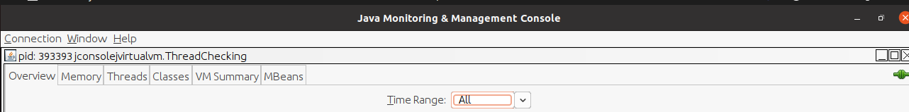
Overview :
Overview tab displays graphical monitoring information about CPU usage, memory usage, thread counts, and the classes loaded in the Java VM, all in a single screen.

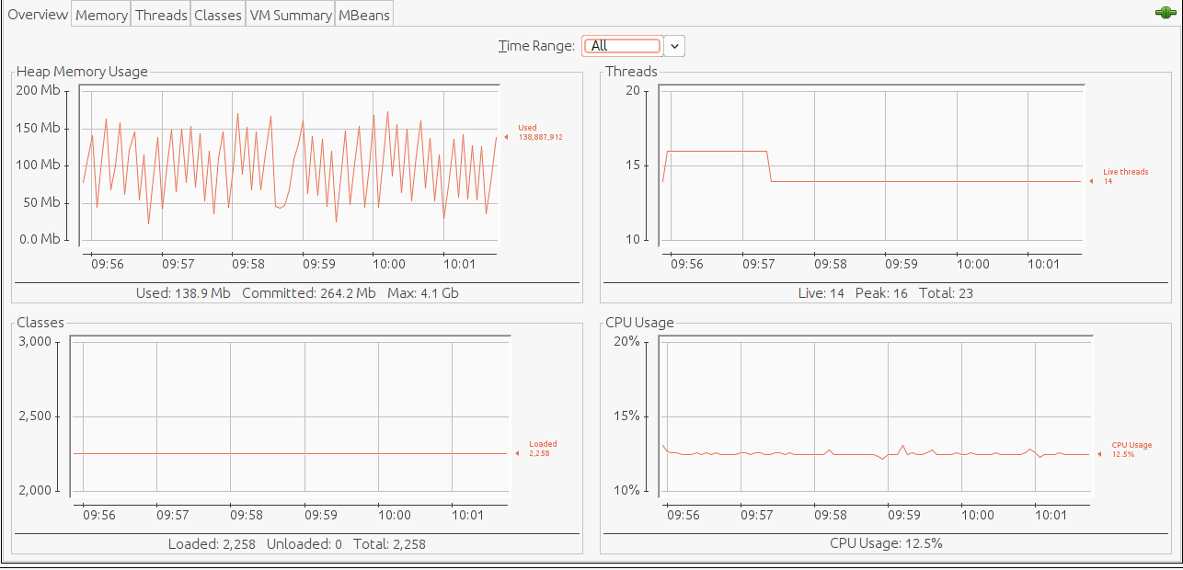

Memory :
Memory tab provides information about memory consumption and memory pools.

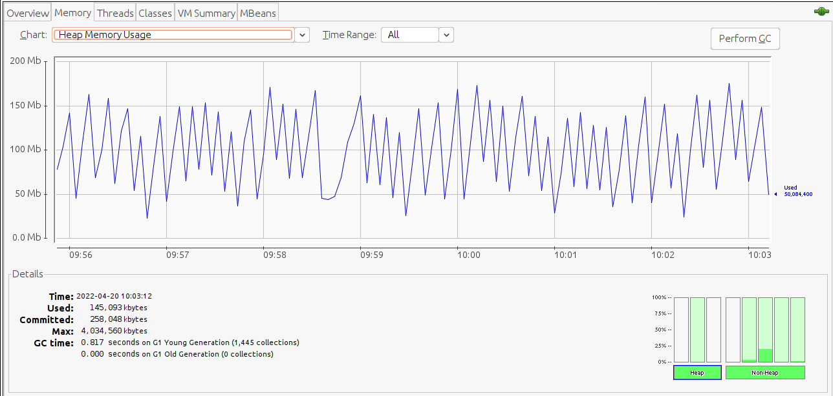
Memory tab features a “Perform GC” button that we can click to perform garbage collection whenever we want. The chart shows the memory use of the Java VM over time, for heap and non-heap memory, as well as for specific memory pools. The memory pools available depend on which version of the Java VM is being used. For the HotSpot Java VM, the memory pools for serial garbage collection are the following.
- Eden Space (heap): The pool from which memory is initially allocated for most objects.
- Survivor Space (heap): The pool containing objects that have survived the garbage collection of the Eden space.
- Tenured Generation (heap): The pool containing objects that have existed for some time in the survivor space.
- Permanent Generation (non-heap): The pool containing all the reflective data of the virtual machine itself, such as class and method objects. With Java VMs that use class data sharing, this generation is divided into read-only and read-write areas.
- Code Cache (non-heap): The HotSpot Java VM also includes a code cache, containing memory that is used for compilation and storage of native code.
The Details area shows several current memory metrics:
- Used: the amount of memory currently used, including the memory occupied by all objects, both reachable and unreachable.
- Committed: the amount of memory guaranteed to be available for use by the Java VM. The amount of committed memory may change over time. The Java virtual machine may release memory to the system and the amount of committed memory could be less than the amount of memory initially allocated at start up. The amount of committed memory will always be greater than or equal to the amount of used memory.
- Max: the maximum amount of memory that can be used for memory management. Its value may change or be undefined. A memory allocation may fail if the Java VM attempts to increase the used memory to be greater than committed memory, even if the amount used is less than or equal to max (for example, when the system is low on virtual memory).
- GC time: the cumulative time spent on garbage collection and the total number of invocations. It may have multiple rows, each of which represents one garbage collector algorithm used in the Java VM.
The bar chart on the lower right-hand side shows the memory consumed by the memory pools in heap and non-heap memory. The bar will turn red when the memory used exceeds the memory usage threshold. we can set the memory usage threshold through an attribute of the MemoryMXBean.

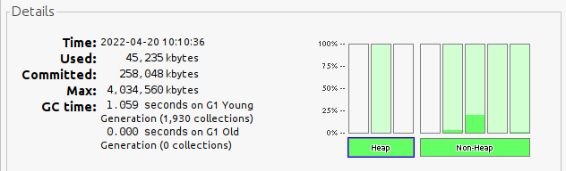

in heap first bar repersents Memory Pool ‘G1 Eden Space’ second one shows Memory Pool “G1Old Gen” and the last one shows Memory Pool “G1 Survivor Space”
in Non Heap there 5 Bars
1. Memory Pool “MetaSpace”
2. Memory Pool “CodeHeap ‘profiled nmethods’”
3. Memory Pool “CodeHeap’non-nmethods’”
4. Memory Pool “Compressed Class Space”
5. Memory Pool “CodeHeap ‘non profiled nmethods’”

Heap memory is the runtime data area from which the Java VM allocates memory for all class instances and arrays. The heap may be of a fixed or variable size. The garbage collector is an automatic memory management system that reclaims heap memory for objects.
Non-heap memory includes a method area shared among all threads and memory required for the internal processing or optimization for the Java VM. It stores per-class structures such as a runtime constant pool, field and method data, and the code for methods and constructors. The method area is logically part of the heap but, depending on the implementation, a Java VM may not garbage collect or compact it. Like the heap memory, the method area may be of a fixed or variable size. The memory for the method area does not need to be contiguous.

Threads :
The chart shows the number of live threads over time. Two lines are shown.
- Red: peak number of threads
- Blue: number of live threads.

Vm Summary :
VM Summary tab provides information about the Java VM.
The information presented in this tab includes the following.
- Summary
  - Uptime: Total amount of time since the Java VM was started.
  - Process CPU Time: Total amount of CPU time that the Java VM has consumed since it was started.
  - Total Compile Time: Total accumulated time spent in JIT compilation. The Java VM determines when JIT compilation occurs. The Hotspot VM uses adaptive compilation, in which the VM launches an application using a standard interpreter, but then analyzes the code as it runs to detect performance bottlenecks, or "hot spots".
- Threads
  - Live threads: Current number of live daemon threads plus non-daemon threads.
  - Peak: Highest number of live threads since Java VM started.
  - Daemon threads: Current number of live daemon threads.
  - Total threads started: Total number of threads started since Java VM started, including daemon, non-daemon, and terminated threads.
- Classes
  - Current classes loaded: Number of classes currently loaded into memory.
  - Total classes loaded: Total number of classes loaded into memory since the Java VM started, including those that have subsequently been unloaded.
  - Total classes unloaded: Number of classes unloaded from memory since the Java VM started.
- Memory
  - Current heap size: Number of kilobytes currently occupied by the heap.
  - Committed memory: Total amount of memory allocated for use by the heap.
  - Maximum heap size: Maximum number of kilobytes occupied by the heap.
  - Objects pending for finalization: Number of objects pending for finalization.
  - Garbage collector: Information about garbage collection, including the garbage collector names, number of collections performed, and total time spent performing GC.
- Operating System
  - Total physical memory: Amount of random-access memory (RAM) the operating system has.
  - Free physical memory: Amount of free RAM available to the operating system.
  - Committed virtual memory: Amount of virtual memory guaranteed to be available to the running process.
- Other Information
  - VM arguments: The input arguments the application passed to the Java VM, not including the arguments to the main method.
  - Class path: The class path that is used by the system class loader to search for class files.
  - Library path: The list of paths to search when loading libraries.
  - Boot class path: The boot class path is used by the bootstrap class loader to search for class files.

Mbeans :
The MBeans tab displays information about all the MBeans registered with the platform MBean server in a generic way. The MBeans tab allows you to access the full set of the platform MXBean instrumentation, including that which is not visible in the other tabs. In addition, you can monitor and manage your application's MBeans using the MBeans tab.

JvisualVM:
Java VisualVM is a tool that provides a visual interface for viewing detailed information about Java technology-based applications (Java applications) while they are running on a Java Virtual Machine (JVM). Java VisualVM organizes JVM data that is retrieved by the Java Development Kit (JDK) tools and presents the information in a way that enables you to quickly view data on multiple Java applications.

jmap -dump:live,format=b,file=heap.hprof 393393 – Heap Dump file using cmd
.hprof -ext of heapdump
jstack 393393 > threaddump.txt – threaddump file using cmd
.tdump – thread dump

heap hero for heapdump analysis
fastThread for threaddump analysis

Minor GC runs when the memory of Eden is full and we need to move some object into Survivor 1 or 2 or remove dead object which created youngly after whenever Minor GC runs Object goes older
When aged objects reach a certain age threshold they are promoted from the young generation to the old generation. This process is called as Promotion
Major GC cleans up the old generation. The task of Major GC is as same as the minor GC, but the only difference is minor GC reclaims the memory of the young generation whereas major GC reclaims the memory of the old generation. It is also said that many major GCs are triggered by minor GCs.

Java Management Extension (JMX) :

The JMX specification defines the architecture, design patterns, APIs, and services in the Java programming language for management and monitoring of applications and networks.
Using the JMX technology, a given resource is instrumented by one or more Java objects known as Managed Beans, or MBeans. These MBeans are registered in a core-managed object server, known as an MBean server. The MBean server acts as a management agent and can run on most devices that have been enabled for the Java programming language.
Jstat :
jstat is a simple utility tool, that is present in JDK to provide JVM performance-related statistics like garbage collection, compilation activities. The major strength of jstat is its ability to capture these metrics dynamically when JVM is running without any pre-requisite instrumentation.
jstat -gc -t 519904 10000 30 :

-gc: garbage collection related statistics will be printed
-t timestamp since JVM was started will be printed
process pid(519904): target JVM process Id
10000: statistics will be printed every 10,000 milliseconds (i.e. 10 seconds).
30: statistics will be printed for 30 iterations. Thus, the above option will cause the JVM to print metrics for 300 seconds (i.e. 10 seconds x 30 iterations).

We can replace -gc by this

Option | Displays...
class | Statistics on the behavior of the class loader.
compiler | Statistics of the behavior of the HotSpot Just-in-Time compiler.
gc | Statistics of the behavior of the garbage collected heap.
gccapacity | Statistics of the capacities of the generations and their corresponding spaces.
gccause | Summary of garbage collection statistics (same as -gcutil), with the cause of the last and current (if applicable) garbage collection events.
gcnew | Statistics of the behavior of the new generation.
gcnewcapacity | Statistics of the sizes of the new generations and its corresponding spaces.
gcold | Statistics of the behavior of the old and permanent generations.
gcoldcapacity | Statistics of the sizes of the old generation.
gcpermcapacity | Statistics of the sizes of the permanent generation.
gcutil | Summary of garbage collection statistics.
printcompilation | HotSpot compilation method statistics.

STATOPTIONS AND OUTPUT
The following tables summarize the columns that jstat outputs for each statOption.

-class Option
Class Loader Statistics
Column | Description
Loaded | Number of classes loaded.
Bytes | Number of Kbytes loaded.
Unloaded | Number of classes unloaded.
Bytes | Number of Kbytes unloaded.
Time | Time spent performing class load and unload operations.

-compiler Option
HotSpot Just-In-Time Compiler Statistics
Column | Description
Compiled | Number of compilation tasks performed.
Failed | Number of compilation tasks that failed.
Invalid | Number of compilation tasks that were invalidated.
Time | Time spent performing compilation tasks.
FailedType | Compile type of the last failed compilation.
FailedMethod | Class name and method for the last failed compilation.

-gc Option
Garbage-collected heap statistics
Column | Description
S0C | Current survivor space 0 capacity (KB).
S1C | Current survivor space 1 capacity (KB).
S0U | Survivor space 0 utilization (KB).
S1U | Survivor space 1 utilization (KB).
EC | Current eden space capacity (KB).
EU | Eden space utilization (KB).
OC | Current old space capacity (KB).
OU | Old space utilization (KB).
PC | Current permanent space capacity (KB).
PU | Permanent space utilization (KB).
YGC | Number of young generation GC Events.
YGCT | Young generation garbage collection time.
FGC | Number of full GC events.
FGCT | Full garbage collection time.
GCT | Total garbage collection time.

Time in sec , S0C+S1C+EC- young generation Capecity,S0U+S1U+EU – young generation utilization

-gccapacity Option
Memory Pool Generation and Space Capacities
Column | Description
NGCMN | Minimum new generation capacity (KB).
NGCMX | Maximum new generation capacity (KB).
NGC | Current new generation capacity (KB).
S0C | Current survivor space 0 capacity (KB).
S1C | Current survivor space 1 capacity (KB).
EC | Current eden space capacity (KB).
OGCMN | Minimum old generation capacity (KB).
OGCMX | Maximum old generation capacity (KB).
OGC | Current old generation capacity (KB).
OC | Current old space capacity (KB).
PGCMN | Minimum permanent generation capacity (KB).
PGCMX | Maximum Permanent generation capacity (KB).
PGC | Current Permanent generation capacity (KB).
PC | Current Permanent space capacity (KB).
YGC | Number of Young generation GC Events.
FGC | Number of Full GC Events.

-gccause Option
This option displays the same summary of garbage collection statistics as the -gcutil option, but includes the causes of the last garbage collection event and (if applicable) the current garbage collection event. In addition to the columns listed for -gcutil, this option adds the following columns:
Garbage Collection Statistics, Including GC Events
Column | Description
LGCC | Cause of last Garbage Collection.
GCC | Cause of current Garbage Collection.

-gcnew Option
New Generation Statistics
Column | Description
S0C | Current survivor space 0 capacity (KB).
S1C | Current survivor space 1 capacity (KB).
S0U | Survivor space 0 utilization (KB).
S1U | Survivor space 1 utilization (KB).
TT | Tenuring threshold.
MTT | Maximum tenuring threshold.
DSS | Desired survivor size (KB).
EC | Current eden space capacity (KB).
EU | Eden space utilization (KB).
YGC | Number of young generation GC events.
YGCT | Young generation garbage collection time.

-gcnewcapacity Option
New Generation Space Size Statistics
Column | Description
NGCMN | Minimum new generation capacity (KB).
NGCMX | Maximum new generation capacity (KB).
NGC | Current new generation capacity (KB).
S0CMX | Maximum survivor space 0 capacity (KB).
S0C | Current survivor space 0 capacity (KB).
S1CMX | Maximum survivor space 1 capacity (KB).
S1C | Current survivor space 1 capacity (KB).
ECMX | Maximum eden space capacity (KB).
EC | Current eden space capacity (KB).
YGC | Number of young generation GC events.
FGC | Number of Full GC Events.

-gcold Option
Old and Permanent Generation Statistics
Column | Description
PC | Current permanent space capacity (KB).
PU | Permanent space utilization (KB).
OC | Current old space capacity (KB).
OU | old space utilization (KB).
YGC | Number of young generation GC events.
FGC | Number of full GC events.
FGCT | Full garbage collection time.
GCT | Total garbage collection time.

-gcoldcapacity Option
Old Generation Statistics
Column | Description
OGCMN | Minimum old generation capacity (KB).
OGCMX | Maximum old generation capacity (KB).
OGC | Current old generation capacity (KB).
OC | Current old space capacity (KB).
YGC | Number of young generation GC events.
FGC | Number of full GC events.
FGCT | Full garbage collection time.
GCT | Total garbage collection time.

-gcutil Option
Summary of Garbage Collection Statistics

Column | Description
S0 | Survivor space 0 utilization as a percentage of the space's current capacity.
S1 | Survivor space 1 utilization as a percentage of the space's current capacity.
E | Eden space utilization as a percentage of the space's current capacity.
O | Old space utilization as a percentage of the space's current capacity.
P | Permanent space utilization as a percentage of the space's current capacity.
YGC | Number of young generation GC events.
YGCT | Young generation garbage collection time.
FGC | Number of full GC events.
FGCT | Full garbage collection time.
GCT | Total garbage collection time.

-printcompilation Option
HotSpot Compiler Method Statistics
Column | Description
Compiled | Number of compilation tasks performed by the most recently compiled method.
Size | Number of bytes of bytecode of the most recently compiled method.
Type | Compilation type of the most recently compiled method.
Method | Class name and method name identifying the most recently compiled method. Class name uses "/" instead of "." as namespace separator. Method name is the method within the given class. The format for these two fields is consistent with the HotSpot - XX:+PrintComplation option.

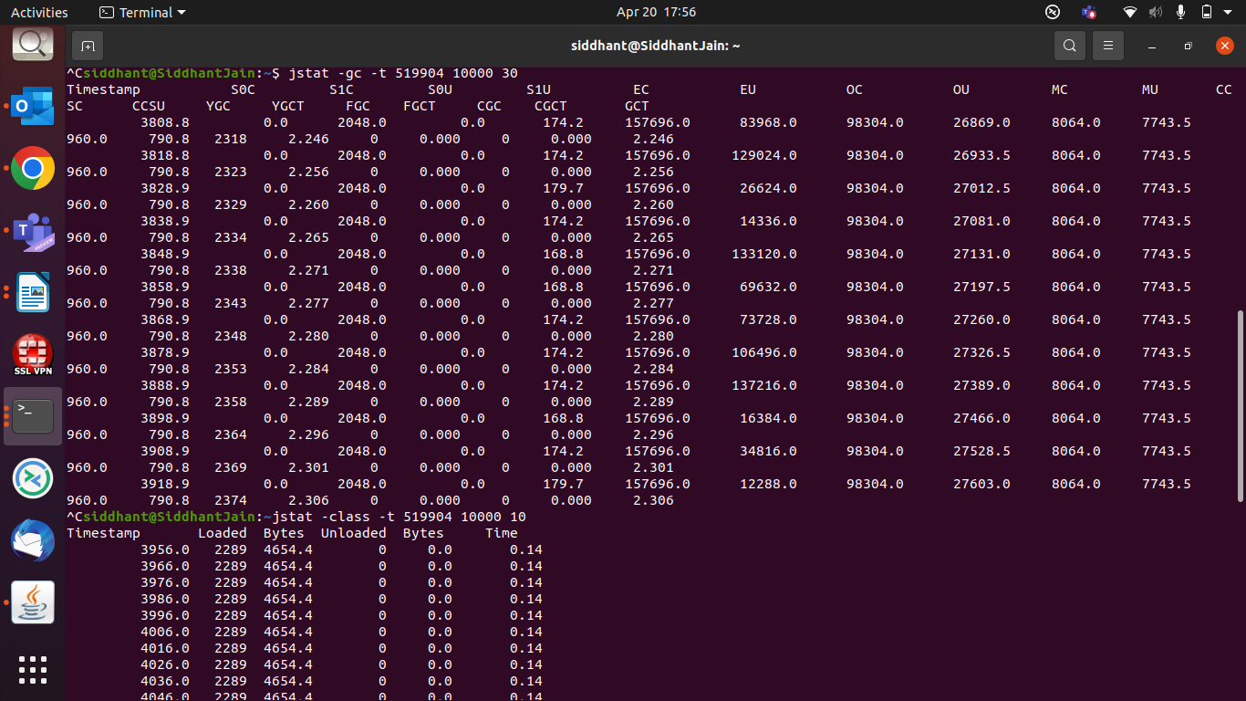
Drawbacks:
(a). jstat doesn’t provide rich detailed information about GC activities. It only provides just enough information.
Example from jstat we will not know:
- If multiple GC events are reported within one-time sample, we wouldn’t know what the pause time of each GC event was.
- How much time is spent in Sys (i.e. kernel), user (i.e. java layer)
- How many GC threads are working and how much time they are taking?
- One GC event has several subphases (like an initial mark, clean-up, remark, concurrent mark….). That break down of information isn’t available.
- How many bytes are reclaimed by each GC event
(b). Sometimes data reported by jstat can be misleading as well.
For accurate GC analysis, GC logs are the more reliable way.

Jmap - prints shared object memory maps or heap memory details of a given process or core file or a remote debug server. If the given process is running on a 64-bit VM, you may need to specify the -J-d64 option

SOCKET PROGRAMMING
Before starting socket programming we need some understanding to basic of networking

Java Networking is a concept of connecting two or more computing devices together so that we can share resources.
Java socket programming provides facility to share data between different computing devices.

Advantage of Java Networking
- Sharing resources
- Centralize software management
The java.net package supports two protocols,
- TCP: Transmission Control Protocol provides reliable communication between the sender and receiver. TCP is used along with the Internet Protocol referred as TCP/IP.
- UDP: User Datagram Protocol provides a connection-less protocol service by allowing packet of data to be transferred along two or more nodes
The widely used Java networking terminologies are given below:
- IP Address : IP address is a unique number assigned to a node of a network e.g. 192.168.0.1 . It is composed of octets that range from 0 to 255. It is a logical address that can be changed.
- Protocol : A protocol is a set of rules basically that is followed for communication. Like TCP,UDP,TELNET,SMTP,POP etc;
- Port Number : The port number is used to uniquely identify different applications. It acts as a communication endpoint between applications. The port number is associated with the IP address for communication between two applications.
- MAC Address : Media Access Control address is a unique identifier of NIC (Network Interface Controller). A network node can have multiple NIC but each with unique MAC address.
- Connection-oriented and connection-less protocol : In connection-oriented protocol, acknowledgement is sent by the receiver. So it is reliable but slow. The example of connection-oriented protocol is TCP. But, in connection-less protocol, acknowledgement is not sent by the receiver. So it is not reliable but fast. The example of connection-less protocol is UDP.
- Socket : A socket is an endpoint between two way communications.
Socket Programing :
Java Socket programming is used for communication between the applications running on different JRE.
Java Socket programming can be connection-oriented or connection-less.
Socket and ServerSocket classes are used for connection-oriented socket programming and DatagramSocket and DatagramPacket classes are used for connection-less socket programming.
The client in socket programming must know two information:
- IP Address of Server, and
- Port number.
The Java URLConnection class represents a communication link between the URL and the application. It can be used to read and write data to the specified resource referred by the URL.

What is the URL?
URL is an abbreviation for Uniform Resource Locator. An URL is a form of string that helps to find a resource on the World Wide Web (WWW).
URL has two components:
- The protocol required to access the resource.
- The location of the resource.
Why to use threads in network programming?
we don’t want only a single client to connect to server at a particular time but many clients simultaneously. We want our architecture to support multiple clients at the same time. For this reason, we must use threads on server side so that whenever a client request comes, a separate thread can be assigned for handling each request.
What is C10K problem ?
The C10k problem is the problem of optimizing network sockets to handle a large number of clients at the same time. The name C10k is a numeronym for concurrently handling ten thousand connections.
At this time the C10K problem came,
The original servers are based on the process/thread model
, A new TCP connection needs to be allocated a process (or thread).
And the process is the most expensive resource of the operating system
, A machine cannot create many processes.
If C10K has to create 10,000 processes, then the operating system cannot afford it
. If a distributed system is adopted, 100,000 servers are required to maintain 100 million users online, which is a huge cost. Only Facebook, Google, and Yahoo have the financial resources to purchase so many servers.
This is the essence of the C10K problem

Solution to C10K problem
From the perspective of network programming technology, the main ideas:
- Each connection is assigned a separate thread/process
- The same thread/process handles multiple connections at the same time

Each process/thread handles one connection
The idea is the most straightforward, but applying for processes/threads requires system resources, and the system needs to manage these processes/threads, so it will occupy too much resources and poor scalability

Each process/thread handles multiple connections at the same time (I/O multiplexing)
Select method:
Use the fd_set structure to tell the kernel to monitor those file handles at the same time, and use the one-by-one troubleshooting method to check whether there are file handles ready or timeout

Disadvantages:
he number of file handles is online, the throughput of checking one by one is low, and the fd_set must be initialized repeatedly for each call

Poll Method :
mainly solves the 2 shortcomings of the select method, the file handle upper limit problem (linked list storage) and the repeated initialization problem (different fields are marked with attention events and occurrence events)

Disadvantage :
checking whether the file handle is ready one by one is still not solved

Epoll method :
This method can be said to be the killer of C10K problems, he does not poll and monitor whether all file handles are ready. epoll is only interested in file handles that have changed working mechanism is to use the "event" ready notification method to register the file descriptor fd through epoll_ctl. Once the fd is ready, the kernel will use a callback mechanism similar to callback to activate the fd, and epoll_wait can be notified and notified application. And epoll uses a file descriptor to manage multiple descriptors, and stores the events of the file descriptor of the user process in an event table of the kernel, so that the data only needs to be copied from the kernel cache space to the user process address space once. Moreover, epoll implements event-ready message transmission by sharing memory between the kernel and the user space, and its efficiency is very high. But epoll is system dependent (Linux).

NGINX was created to solve the well-known C10k problem
NGINX is an open-source web server which can also act as a reverse proxy server, load balancer, HTTP cache, and a mail proxy server.

NGINX mainly focus on the below:
- High Performance – Fast
- Low Resource Usage – Memory Efficient
- High Concurrency
Because it can handle a high volume of connections, NGINX is commonly used as a reverse proxy and load balancer to manage incoming traffic and distribute it to slower upstream servers – anything from legacy database servers to microservices.

To Overcome we shifting thread based server like apache to event based server where don’t have to wait to send messages like NGINX.

Why Server gets stuck when we creating 1000’s client and sending messages?
Well every client runs to different port in client and bind with server to one port and in TCP roughly <10000 ports and available to use so due to unavailablity of ports server can’t handle new client
or backlog of pending connections is also one of problem and also when firewall Blocking in between Client to server.

Message Driven Programming (ZMQ)

ZeroMQ (also spelled ØMQ, 0MQ or ZMQ) is a high-performance asynchronous messaging library, aimed at use in distributed or concurrent applications. It provides a message queue, but unlike message-oriented middleware, a ZeroMQ system can run without a dedicated message broker.
ZeroMQ supports common messaging patterns (pub/sub, request/reply, client/server and others) over a variety of transports (TCP, in-process, inter-process, multicast, WebSocket and more), making inter-process messaging as simple as inter-thread messaging.
zero is for zero broker (ZeroMQ is brokerless), zero latency, zero cost (it’s free), and zero administration.
It is used for high performance for asynchronous messaging.

ZMQ Message Pattern :
Synchronous Request/Response : once the request sent it blocked the application and wait for response
Asynchronous Request/Response : Did not make client to wait for responses
publish/ Subscribe
Push / Pull
Exckusive Pair

DATABASE
A database is information that is set up for easy access, management and updating. Computer databases typically store aggregations of data records or files that contain information, such as sales transactions, customer data, financials and product information

Key is an attribute or set of attribute that uniquely identifies any record (or tuples ) from the data.

Types of Keys :

Super Key : Combitions of all possible attribute which can uniquely identify any record and it is a super set of candidate key.
Candidate Key : A candidate key is an attribute or set of attributes that can uniquely identify a tuple. Except for the primary key, the remaining attributes are considered a candidate key. The candidate keys are as strong as the primary key.
Primary Key : it is not null and unique and never be update once it created and also it should be part of CK or SK and every new entry must contains this
Alternate Key : except of PK all other CK can be addressed as AK.
Foriegn Key : Foreign keys are the column of the table used to point to the primary key of another table.
Composite Key : Whenever a primary key consists of more than one attribute, it is known as a composite key. This key is also known as Concatenated Key.
Artficial Key : The key created using arbitrarily assigned data are known as artificial keys. These keys are created when a primary key is large and complex and has no relationship with many other relations. The data values of the artificial keys are usually numbered in a serial order.

ACID Properties :
Atomicity : means if any operation is performed on the data, either it should be performed or executed completely or should not be executed at all. It further means that the operation should not break in between or execute partially. In the case of executing operations on the transaction, the operation should be completely executed and not partially.
Consistancy : means that the value should remain preserved always. In DBMS,the integrity of the data should be maintained, which means if a change in the database is made, it should remain preserved always. In the case of transactions, the integrity of the data is very essential so that the database remains consistent before and after the transaction. The data should always be correct.
Isolation : means separation. In DBMS, Isolation is the property of a database where no data should affect the other one and may occur concurrently. In short, the operation on one database should begin when the operation on the first database gets complete. It means if two operations are being performed on two different databases, they may not affect the value of one another. In the case of transactions, when two or more transactions occur simultaneously, the consistency should remain maintained. Any changes that occur in any particular transaction will not be seen by other transactions until the change is not committed in the memory.
Durability : ensures the permanency of something. In DBMS, the term durability ensures that the data after the successful execution of the operation becomes permanent in the database. The durability of the data should be so perfect that even if the system fails or leads to a crash, the database still survives. However, if gets lost, it becomes the responsibility of the recovery manager for ensuring the durability of the database. For committing the values, the COMMIT command must be used every time we make changes.
Normalization :
Fuctional Dependancy :functional dependency is a relationship that exists between two attributes. It typically exists between the primary key and non-key attribute within a table
X ---> Y means x determines Y or Y determined by X.

What is Normalization?
Normalization is the process of organizing the data in the database.
Normalization is used to minimize the redundancy from a relation or set of relations. It is also used to eliminate undesirable characteristics like Insertion, Update, and Deletion Anomalies.
Normalization divides the larger table into smaller and links them using relationships.
The normal form is used to reduce redundancy from the database table.
Data modification anomalies can be categorized into three types:
Insertion Anomaly: Insertion Anomaly refers to when one cannot insert a new tuple into a relationship due to lack of data.
Deletion Anomaly: The delete anomaly refers to the situation where the deletion of data results in the unintended loss of some other important data.
Updatation Anomaly: The update anomaly is when an update of a single data value requires multiple rows of data to be updated.
Types of Normalization :
1st NF : No mutlivalued Attribute present in table (eg : A---->B,C)
2nd NF : it should be in 1st NF and there no partial dependancy it means only full dependency in table(eg: AB----> C then A—x-> C or B—x--> C)
3rd NF : it should follow 2nd NF and there is No transitive dependency in table or No non prime attribute can determine Non Prime Attribute. (eg A---B B--->C so A--->C no possible in 3rd NF)

BCNF(Boyee-codd NF) : folloe 3rd NF and in Left hand side there must be CK or SK
4th NF : follow BCNF with No multivalued Dependency
5th NF : it should be in 4th NF and lossless Decompostion occur.

Prime attribute − An attribute, which is a part of the prime-key, is known as a prime attribute.
Non-prime attribute − An attribute, which is not a part of the prime-key, is said to be a nonprime attribute.
Lossless Decomposition : Decomposition is lossless if it is feasible to reconstruct relation R from decomposed tables using Joins. This is the preferred choice. The information will not lose from the relation when decomposed. The join would result in the same original relation.

Lossy Decomposition :As the name suggests, when a relation is decomposed into two or more relational schemas, the loss of information is unavoidable when the original relation is retrieved.

Index | SQL | NoSQL
1) | Databases are categorized as Relational Database Management System (RDBMS). | NoSQL databases are categorized as Non-relational or distributed database system.
2) | SQL databases have fixed or static or predefined schema. | NoSQL databases have dynamic schema.
3) | SQL databases display data in form of tables so it is known as table-based database. | NoSQL databases display data as collection of key-value pair, documents, graph databases or wide-column stores.
4) | SQL databases are vertically scalable. | NoSQL databases are horizontally scalable.
5) | SQL databases use a powerful language "Structured Query Language" to define and manipulate the data. | In NoSQL databases, collection of documents are used to query the data. It is also called unstructured query language. It varies from database to database.
6) | SQL databases are best suited for complex queries. | NoSQL databases are not so good for complex queries because these are not as powerful as SQL queries.
7) | SQL databases are not best suited for hierarchical data storage. | NoSQL databases are best suited for hierarchical data storage.
8) | MySQL, Oracle, Sqlite, PostgreSQL and MS-SQL etc. are the example of SQL database. | MongoDB, BigTable, Redis, RavenDB, Cassandra, Hbase, Neo4j, CouchDB etc. are the example of nosql database

A time-series database (TSDB) is a computer system that is designed to store and retrieve data records that are part of a “time series,” which is a set of data points that are associated with timestamps. The timestamps provide a critical context for each of the data points in how they are related to others. Time series data is often a continuous flow of data like measurements from sensors and intraday stock prices. A time-series database lets you store large volumes of timestamped data in a format that allows fast insertion and fast retrieval to support complex analysis on that data.

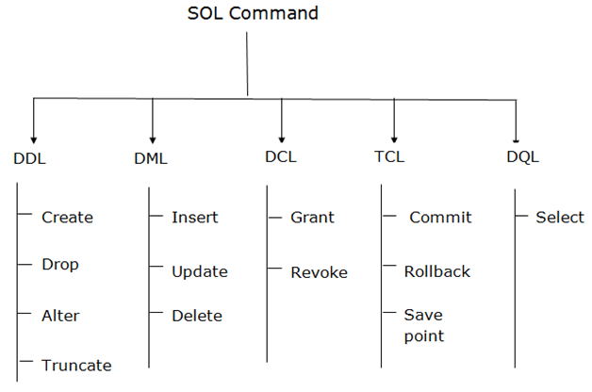

DDL :
DDL changes the structure of the table like creating a table, deleting a table, altering a table, etc.
All the command of DDL are auto-committed that means it permanently save all the changes in the database.
Create Command : CREATE TABLE TABLE_NAME (COLUMN_NAME DATATYPES[,....]);

CREATE TABLE Persons (
Personid int NOT NULL AUTO_INCREMENT,
LastName varchar(255) NOT NULL,
FirstName varchar(255),
Age int,
PRIMARY KEY (Personid)
);

JDBC Database Access :
The JDBC API was designed to keep simple things simple. This means that the JDBC makes everyday database tasks easy. This trail walks you through examples of using JDBC to execute common SQL statements, and perform other objectives common to database applications.

SQL Queries :
//Create table
create table employees(employee_id int NOT NULL AUTO_INCREMENT, name varchar(255) NOT NULL, age int NOT NULL,city varchar(255) NOT NULL, dob DATE NOT NULL,department_id int NOT NULL,PRIMARY KEY(employee_id));

//drop table
drop table employees

//Alter table
// -> add column
alter table test add column city varchar(255);

// -> Modify column
alter table test modify column city varchar(255) NOT NULL;

// -> drop column
alter table test drop column city;

// truncate table
truncate table test;

// select data from table (* means ALl)
Select * from table;

//insert data
insert into employees(name,age,city,dob,department_id)values("vedant",21,"surat",'010101',1);

//update data for column
UPDATE employees SET dob = 010125 WHERE employee_id =1;

// decription table
desc table_name;

// make foreign keyif table exits (only when column exits in both tables)
Alter table employees ADD FOREIGN KEY (department_id) REFERENCES departments(department_id);

// delete table
delete from departments where department_id = 3;

// some where queries
Select * from students where class = 12;

// perform func of tables
max func with nested

Select * from students where class = 12 and marks1 =(Select max(marks1) from students);
+------+--------+-------+--------+--------+--------+--------+--------+
| s_id | name | class | marks1 | marks2 | marks3 | marks4 | marks5 |
+------+--------+-------+--------+--------+--------+--------+--------+
| 3 | smith | 12 | 100 | 99 | 87 | 89 | 82 |
| 4 | vedant | 12 | 100 | 99 | 87 | 89 | 92 |
| 5 | umang | 12 | 100 | 90 | 80 | 89 | 90 |
+------+--------+-------+--------+--------+--------+--------+--------+

min func :

Select * from students where class = 12 and marks1 =(Select min(marks1) from students);
+------+----------+-------+--------+--------+--------+--------+--------+
| s_id | name | class | marks1 | marks2 | marks3 | marks4 | marks5 |
+------+----------+-------+--------+--------+--------+--------+--------+
| 1 | siddhant | 12 | 98 | 99 | 87 | 89 | 100 |
+------+----------+-------+--------+--------+--------+--------+--------+

// count specific
select count(s_id) from students where class=12;
+-------------+
| count(s_id) |
+-------------+
| 5 |
+-------------+
1 row in set (0.00 sec)

// Avg
Select Avg(marks1+marks2+marks3+marks4+marks5) from students ;
+-----------------------------------------+
| Avg(marks1+marks2+marks3+marks4+marks5) |
+-----------------------------------------+
| 461.8333 |
+-----------------------------------------+
1 row in set (0.00 sec)

//Distinct =statement is used to return only distinct (different) values.
select DISTINCT class from students;
+-------+
| class |
+-------+
| 12 |
| 11 |
+-------+

// top clause is used to specify the number of records to return.

select * from students where s_id<=4;
+------+----------+-------+--------+--------+--------+--------+--------+
| s_id | name | class | marks1 | marks2 | marks3 | marks4 | marks5 |
+------+----------+-------+--------+--------+--------+--------+--------+
| 1 | siddhant | 12 | 98 | 99 | 87 | 89 | 100 |
| 2 | mohit | 12 | 99 | 99 | 87 | 89 | 82 |
| 3 | smith | 12 | 100 | 99 | 87 | 89 | 82 |
| 4 | vedant | 12 | 100 | 99 | 87 | 89 | 92 |
+------+----------+-------+--------+--------+--------+--------+--------+
4 rows in set (0.00 sec)

mysql> select * from students where s_id<=4 LIMIT 3;
+------+----------+-------+--------+--------+--------+--------+--------+
| s_id | name | class | marks1 | marks2 | marks3 | marks4 | marks5 |
+------+----------+-------+--------+--------+--------+--------+--------+
| 1 | siddhant | 12 | 98 | 99 | 87 | 89 | 100 |
| 2 | mohit | 12 | 99 | 99 | 87 | 89 | 82 |
| 3 | smith | 12 | 100 | 99 | 87 | 89 | 82 |
+------+----------+-------+--------+--------+--------+--------+--------+
3 rows in set (0.00 sec)

// between
select * from students where (marks1+marks2+marks3+marks4+marks5)/5 between 92 And 100;
+------+----------+-------+--------+--------+--------+--------+--------+
| s_id | name | class | marks1 | marks2 | marks3 | marks4 | marks5 |
+------+----------+-------+--------+--------+--------+--------+--------+
| 1 | siddhant | 12 | 98 | 99 | 87 | 89 | 100 |
| 4 | vedant | 12 | 100 | 99 | 87 | 89 | 92 |
| 6 | meet | 11 | 100 | 100 | 90 | 89 | 90 |
+------+----------+-------+--------+--------+--------+--------+--------+

//SQL aliases are used to give a table, or a column in a table, a temporary name.

//JOINS : A JOIN clause is used to combine rows from two or more tables, based on a related column between them.

OUTER JOIN in SQL Server returns all records from both tables that satisfy the join condition.

The INNER JOIN keyword selects records that have matching values in both tables.
The INNER JOIN keyword selects all rows from both tables as long as there is a match between the columns. If there are records in the "employees" table that do not have matches in "departments", these orders will not be shown!

select * from employees INNER JOIN departments ON employees.department_id
+-------------+----------+-----+----------+------------+---------------+---------------+-----------------+
| employee_id | name | age | city | dob | department_id | department_id | department_name |
+-------------+----------+-----+----------+------------+---------------+---------------+-----------------+
| 1 | vedant | 21 | surat | 2001-01-01 | 1 | 1 | Development 8.0 |
| 2 | Siddhant | 21 | Bhilwara | 2001-01-25 | 1 | 1 | Development 8.0 |
| 4 | GK | 21 | Bhilwara | 2001-01-25 | 2 | 2 | Development 7.0 |
| 5 | MOhit | 21 | Bhilwara | 2001-02-25 | 4 | 4 | ITSM |
+-------------+----------+-----+----------+------------+---------------+---------------+-----------------+
4 rows in set (0.00 sec)

select * from employees;
+-------------+----------+-----+----------+------------+---------------+
| employee_id | name | age | city | dob | department_id |
+-------------+----------+-----+----------+------------+---------------+
| 1 | vedant | 21 | surat | 2001-01-01 | 1 |
| 2 | Siddhant | 21 | Bhilwara | 2001-01-25 | 1 |
| 4 | GK | 21 | Bhilwara | 2001-01-25 | 2 |
| 5 | MOhit | 21 | Bhilwara | 2001-02-25 | 4 |
| 6 | shruti | 21 | kota | 2001-05-27 | NULL |
+-------------+----------+-----+----------+------------+---------------+
5 rows in set (0.00 sec)

Select * from departments LEFT JOIN employees ON employees.department_id=departments.department_id;
+---------------+-----------------+-------------+----------+------+----------+------------+---------------+
| department_id | department_name | employee_id | name | age | city | dob | department_id |
+---------------+-----------------+-------------+----------+------+----------+------------+---------------+
| 1 | Development 8.0 | 1 | vedant | 21 | surat | 2001-01-01 | 1 |
| 1 | Development 8.0 | 2 | Siddhant | 21 | Bhilwara | 2001-01-25 | 1 |
| 2 | Development 7.0 | 4 | GK | 21 | Bhilwara | 2001-01-25 | 2 |
| 4 | ITSM | 5 | MOhit | 21 | Bhilwara | 2001-02-25 | 4 |
+---------------+-----------------+-------------+----------+------+----------+------------+---------------+
4 rows in set (0.00 sec)

Select * from employees LEFT OUTER JOIN departments ON employees.department_id=departments.department_id;
+-------------+----------+-----+----------+------------+---------------+---------------+-----------------+
| employee_id | name | age | city | dob | department_id | department_id | department_name |
+-------------+----------+-----+----------+------------+---------------+---------------+-----------------+
| 1 | vedant | 21 | surat | 2001-01-01 | 1 | 1 | Development 8.0 |
| 2 | Siddhant | 21 | Bhilwara | 2001-01-25 | 1 | 1 | Development 8.0 |
| 4 | GK | 21 | Bhilwara | 2001-01-25 | 2 | 2 | Development 7.0 |
| 5 | MOhit | 21 | Bhilwara | 2001-02-25 | 4 | 4 | ITSM |
| 6 | shruti | 21 | kota | 2001-05-27 | NULL | NULL | NULL |
+-------------+----------+-----+----------+------------+---------------+---------------+-----------------+

Select * from employees RIGHT OUTER JOIN departments ON employees.department_id=departments.department_id;
+-------------+----------+------+----------+------------+---------------+---------------+-----------------+
| employee_id | name | age | city | dob | department_id | department_id | department_name |
+-------------+----------+------+----------+------------+---------------+---------------+-----------------+
| 1 | vedant | 21 | surat | 2001-01-01 | 1 | 1 | Development 8.0 |
| 2 | Siddhant | 21 | Bhilwara | 2001-01-25 | 1 | 1 | Development 8.0 |
| 4 | GK | 21 | Bhilwara | 2001-01-25 | 2 | 2 | Development 7.0 |
| 5 | MOhit | 21 | Bhilwara | 2001-02-25 | 4 | 4 | ITSM |
+-------------+----------+------+----------+------------+---------------+---------------+-----------------+
4 rows in set (0.00 sec)

// Self join : A table is joined to itself using the SELF JOIN. It means that each table row is combined with itself and with every other table row.
Select DISTINCT t1.s_id,t1.name from students t1,students t2 where t1.s_id <> t2.s_id and t1.marks1 < t2.marks2;
+------+----------+
| s_id | name |
+------+----------+
| 1 | siddhant |
| 2 | mohit |
+------+----------+

// cross join :
CROSS JOIN in SQL Server combines all of the possibilities of two or more tables and returns a result that includes every row from all contributing tables. It's also known as CARTESIAN JOIN because it produces the Cartesian product of all linked tables.

Select * from employees cross join departments where employees.department_id = departments.department_id;

Select * from employees cross join departments where employees.department_id = departments.department_id;
+-------------+----------+-----+----------+------------+---------------+---------------+-----------------+
| employee_id | name | age | city | dob | department_id | department_id | department_name |
+-------------+----------+-----+----------+------------+---------------+---------------+-----------------+
| 1 | vedant | 21 | surat | 2001-01-01 | 1 | 1 | Development 8.0 |
| 2 | Siddhant | 21 | Bhilwara | 2001-01-25 | 1 | 1 | Development 8.0 |
| 4 | GK | 21 | Bhilwara | 2001-01-25 | 2 | 2 | Development 7.0 |
| 5 | MOhit | 21 | Bhilwara | 2001-02-25 | 4 | 4 | ITSM |
+-------------+----------+-----+----------+------------+---------------+---------------+-----------------+

//Clauses
Distinct : DISTINCT clause is used to remove duplicates from the table. The DISTICT clause is only used with SELECT statement.

Select distinct name from students where class>11 and marks5>90;
+----------+
| name |
+----------+
| siddhant |
| vedant |
+----------+
2 rows in set (0.00 sec)

mysql> Select * from students where class>11 and marks5>90;
+------+----------+-------+--------+--------+--------+--------+--------+
| s_id | name | class | marks1 | marks2 | marks3 | marks4 | marks5 |
+------+----------+-------+--------+--------+--------+--------+--------+
| 1 | siddhant | 12 | 98 | 99 | 87 | 89 | 100 |
| 4 | vedant | 12 | 100 | 99 | 87 | 89 | 92 |
| 7 | siddhant | 12 | 100 | 100 | 90 | 90 | 98 |
+------+----------+-------+--------+--------+--------+--------+--------+
3 rows in set (0.00 sec)

GROUP BY clause is used to collect data across multiple records and group the results by one or more columns. It is used with SELECT statement.
expression1, expression2, ... expression_n: These expressions are not encapsulated within an aggregate function and must be included in the GROUP BY clause.
aggregate_function: It can be a function such as SUM, COUNT, MIN, MAX, or AVG functions.

select sum(salary),department_id from employees group by department_id;
+-------------+---------------+
| sum(salary) | department_id |
+-------------+---------------+
| NULL | NULL |
| 50000 | 1 |
| 25000 | 2 |
| 25000 | 4 |
+-------------+---------------+

WHERE clause in SQL Server is used to filter records from the table
The WHERE clause can also work with the UPDATE and DELETE query.

//Order by default Asec
select * from students order by marks1+marks2+marks3+marks4+marks5;
+------+----------+-------+--------+--------+--------+--------+--------+
| s_id | name | class | marks1 | marks2 | marks3 | marks4 | marks5 |
+------+----------+-------+--------+--------+--------+--------+--------+
| 5 | umang | 12 | 100 | 90 | 80 | 89 | 90 |
| 2 | mohit | 12 | 99 | 99 | 87 | 89 | 82 |
| 3 | smith | 12 | 100 | 99 | 87 | 89 | 82 |
| 4 | vedant | 12 | 100 | 99 | 87 | 89 | 92 |
| 6 | meet | 11 | 100 | 100 | 90 | 89 | 90 |
| 1 | siddhant | 12 | 98 | 99 | 87 | 89 | 100 |
+------+----------+-------+--------+--------+--------+--------+--------+

Having : The HAVING clause validates groups in the same way as the WHERE clause validates individual rows. The main benefit of using a HAVING clause is that aggregates can be included in the search condition, whereas aggregates cannot be used in a WHERE clause's search condition.

HAVING clause in SQL Server is used to specify the search condition for a group or an aggregate. It can only work with the SELECT statement and is usually used with the GROUP BY clause.

select sum(salary),department_id from employees group by department_id having sum(salary)>26000;
+-------------+---------------+
| sum(salary) | department_id |
+-------------+---------------+
| 50000 | 1 |
+-------------+---------------+
1 row in set (0.00 sec)

Grouping set :
select count(employee_id),sum(salary) from employees group by department_id having department_id=1;
+--------------------+-------------+
| count(employee_id) | sum(salary) |
+--------------------+-------------+
| 2 | 50000 |
+--------------------+-------------+

// IS NOT NULL
select count(employee_id),sum(salary) from employees group by department_id having department_id is not NULL;
+--------------------+-------------+
| count(employee_id) | sum(salary) |
+--------------------+-------------+
| 2 | 50000 |
| 1 | 25000 |
| 1 | 25000 |
+--------------------+-------------+
3 rows in set (0.00 sec)
// IS NULL
select count(employee_id),sum(salary) from employees group by department_id having department_id is NULL;
+--------------------+-------------+
| count(employee_id) | sum(salary) |
+--------------------+-------------+
| 1 | NULL |
+--------------------+-------------+
1 row in set (0.00 sec)

// in
select t1.department_id,t1.department_name from departments as t1 cross join employees as t2 where t1.department_id in (t2.department_id);
+---------------+-----------------+
| department_id | department_name |
+---------------+-----------------+
| 1 | Development 8.0 |
| 1 | Development 8.0 |
| 2 | Development 7.0 |
| 4 | ITSM |
+---------------+-----------------+
4 rows in set (0.00 sec)

select * from departments
-> ;
+---------------+-----------------+
| department_id | department_name |
+---------------+-----------------+
| 1 | Development 8.0 |
| 2 | Development 7.0 |
| 3 | DevOps |
| 4 | ITSM |
| 5 | HR |
| 6 | Sales |
+---------------+-----------------+
6 rows in set (0.00 sec)

select distinct t1.department_id,t1.department_name from departments as t1 cross join employees as t2 where t1.department_id in (t2.department_id);
+---------------+-----------------+
| department_id | department_name |
+---------------+-----------------+
| 1 | Development 8.0 |
| 2 | Development 7.0 |
| 4 | ITSM |
+---------------+-----------------+
3 rows in set (0.00 sec)

EXIST condition is used in combination with a subquery. It returns at least one row after met the conditions. It can be used in a SELECT, INSERT, UPDATE, or DELETE statement.

select * from departments where exists(select * from employees where departments.department_id = employees.department_id);
+---------------+-----------------+
| department_id | department_name |
+---------------+-----------------+
| 1 | Development 8.0 |
| 2 | Development 7.0 |
| 4 | ITSM |
+---------------+-----------------+
3 rows in set (0.00 sec)

in comparision operators are used to test for equality and inequality. These operators are used in the WHERE clause to determine which records to select.

select * from employees where employee_id > 4;
+-------------+--------+-----+----------+------------+---------------+--------+
| employee_id | name | age | city | dob | department_id | salary |
+-------------+--------+-----+----------+------------+---------------+--------+
| 5 | MOhit | 21 | Bhilwara | 2001-02-25 | 4 | 25000 |
| 6 | shruti | 21 | kota | 2001-05-27 | NULL | NULL |
+-------------+--------+-----+----------+------------+---------------+--------+
2 rows in set (0.00 sec)

select * from employees where employee_id >= 4;
+-------------+--------+-----+----------+------------+---------------+--------+
| employee_id | name | age | city | dob | department_id | salary |
+-------------+--------+-----+----------+------------+---------------+--------+
| 4 | GK | 21 | Bhilwara | 2001-01-25 | 2 | 25000 |
| 5 | MOhit | 21 | Bhilwara | 2001-02-25 | 4 | 25000 |
| 6 | shruti | 21 | kota | 2001-05-27 | NULL | NULL |
+-------------+--------+-----+----------+------------+---------------+--------+
3 rows in set (0.00 sec)

LIKE operator is used in a WHERE clause to search for a specified pattern in a column.
There are two wildcards often used in conjunction with the LIKE operator:
The percent sign (%) represents zero, one, or multiple characters
The underscore sign (_) represents one, single character

select * from employees where name like "s%";
+-------------+----------+-----+----------+------------+---------------+--------+
| employee_id | name | age | city | dob | department_id | salary |
+-------------+----------+-----+----------+------------+---------------+--------+
| 2 | Siddhant | 21 | Bhilwara | 2001-01-25 | 1 | 25000 |
| 6 | shruti | 21 | kota | 2001-05-27 | NULL | NULL |
+-------------+----------+-----+----------+------------+---------------+--------+
2 rows in set (0.00 sec)

select * from employees where name like "_h%";
+-------------+--------+-----+------+------------+---------------+--------+
| employee_id | name | age | city | dob | department_id | salary |
+-------------+--------+-----+------+------------+---------------+--------+
| 6 | shruti | 21 | kota | 2001-05-27 | NULL | NULL |

Asynchronous Programming :
it was ready to accomodate for the lag between when a function is called to when the value of that function is returned.
Without asynchronous programming, apps would spend a long time on loading screens. A loading screen might appear:
When a user signs in, waiting for all their user data to be returned from the database.
During the user experience, waiting for the data to load at each new screen.
Asynchronous programming allows a user to go about his business in an application, whlie process run in the background, thus enhancing the user experience.

How Asychronous programming works:

Synchronous programming :
it follows a strict set of sequences.
It follow each step of an algorithm.
It does so in order and will wait for the present operation to finish before start or continuing on the next.
It has a one track mind and it follows the guide step by step.
Asynchronous function are often found in front end application and used particularly in independent, Io tasks, high volume. Front end applications benifit from its use because it enhances the flow of an application.
Backend processes may use asynchronous functions to run many tasks or make lots of network calls. In the backend, asynchronous programming allows the computer to do more, faster. It calls a lot of functions whose response times are indefinite and processing the results.

Syntax:
async function foo() {
const value = await somePromise();
return value;
}

VERTEX
What is a Vertex?
-> Vertex is a toolkit which have the core library defines the fundamental APIs for writing asynchronous networked applications, and then you can pick the useful modules for yourapplication (e.g., database connection, monitoring, authentication, logging, service discovery,clustering support, etc).
Based on nettey project
Netty is a NIO client server framework which enables quick and easy development of network applications such as protocol servers and clients. It greatly simplifies and streamlines network programming such as TCP and UDP socket server.

Vert.x was designed for asynchronous communications it can deal with more concurrent network connections with less threads than synchronous APIs such as Java servlets or java.net socket classes. Vert.x is useful for a large range of applications: high volume message / eventprocessing, micro-services, API gateways, HTTP APIs for mobile applications, etc. Vert.x and itsecosystem provide all sorts of technical tools for building end-to-end reactive applications.

Core Vert.x concepts
There are 2 key concepts to learn in Vert.x:
1.what a verticle is, and
2.how the event bus allows verticles to communicate.
The unit of deployment in Vert.x is called a Verticle. A verticle processes incoming events over an event-loop, where events can be anything like receiving network buffers, timing events, or messages sent by other verticles.
Vert.x offers mechanisms to deal with blocking operations outside of the event loop. In any case Vert.x emits warnings in logs when the event loop has been processing an event for too long, which is also configurable to match application-specific requirements (e.g., when working on slower IoT ARM boards).
Every event loop is attached to a thread. By default Vert.x attaches 2 event loops per CPU core thread. The direct consequence is that a regular verticle always processes events on the same thread, so there is no need to use thread coordination mechanisms to manipulate a verticle state (e.g java class field)
A vertical can be passed some configuration (e.g., credentials, network addresses, etc) and a verticle
can be deployed several times
Incoming network data are being received from accepting threads then passed as events to the
corresponding verticles. When a verticle opens a network server and is deployed more than once,
then the events are being distributed to the verticle instances in a round-robin fashion which is
very useful for maximizing CPU usage with lots of concurrent networked requests. Finally, verticles
have a simple start / stop life-cycle, and verticles can deploy other verticles.

Event Bus:
Verticles form technical units of deployments of code in Vert.x. The Vert.x event bus is the main tool for different verticles to communicate through asynchronous message passing. For instance suppose that we have a verticle for dealing with HTTP requests, and a verticle for managing access to the database. The event bus allows the HTTP verticle to send a request to the database verticle that performs a SQL query, and responds back to the HTTP verticle
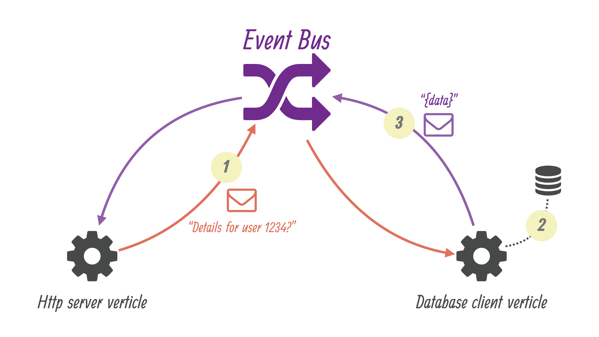
The Event bus is a nervous system of vert.x
Communication in a thread-safe non-blocking way
The event bus supports :
publish subscribe messaging
point to point messaging
request -response messaging

With very few exceptions (i.e. some file system operations ending in 'Sync'), none of the APIs in Vert.x block the calling thread.
If a result can be provided immediately, it will be returned immediately, otherwise you will usually provide a handler to receive events some time later.
Because none of the Vert.x APIs block threads that means you can use Vert.x to handle a lot of concurrency using just a small number of threads.

Reactor and Multi-Reactor :
Vert.x APIs are event driven - Vert.x passes events to handlers when they are available.
In most cases Vert.x calls your handlers using a thread called an event loop.
As nothing in Vert.x or your application blocks, the event loop can merrily run around delivering events to different handlers in succession as they arrive.
Because nothing blocks, an event loop can potentially deliver huge amounts of events in a short amount of time. For example a single event loop can handle many thousands of HTTP requests very quickly.
We call this the Reactor Pattern.

In a standard reactor implementation there is a single event loop thread which runs around in a loop delivering all events to all handlers as they arrive.
The trouble with a single thread is it can only run on a single core at any one time, so if you want your single threaded reactor application (e.g. your Node.js application) to scale over your multi-core server you have to start up and manage many different processes.
Vert.x works differently here. Instead of a single event loop, each Vertx instance maintains several event loops. By default we choose the number based on the number of available cores on the machine, but this can be overridden.
This means a single Vertx process can scale across your server, unlike Node.js.
We call this pattern the Multi-Reactor Pattern to distinguish it from the single threaded reactor pattern.
Even though a Vertx instance maintains multiple event loops, any particular handler will never be executed concurrently, and in most cases (with the exception of worker verticles) will always be called using the exact same event loop.

Vert.x APIs are non blocking and won’t block the event loop, but that’s not much help if you block the event loop yourself in a handler.
If you do that, then that event loop will not be able to do anything else while it’s blocked. If you block all of the event loops in Vertx instance then your application will grind to a complete halt!
So don’t do it! You have been warned.
Examples of blocking include:
- Thread.sleep()
- Waiting on a lock
- Waiting on a mutex or monitor (e.g. synchronized section)
- Doing a long lived database operation and waiting for a result
- Doing a complex calculation that takes some significant time.
- Spinning in a loop
If any of the above stop the event loop from doing anything else for a significant amount of time then you should go immediately to the naughty step, and await further instructions.

If you have a single event loop, and you want to handle 10000 http requests per second, then it’s clear that each request can’t take more than 0.1 ms to process, so you can’t block for any more time than that.
application is not responsive it might be a sign that you are blocking an event loop somewhere. To help you diagnose such issues, Vert.x will automatically log warnings if it detects an event loop hasn’t returned for some time.

Vertx Web :
A Router is one of the core concepts of Vert.x-Web. It’s an object which maintains zero or more Routes.
A router takes an HTTP request and finds the first matching route for that request, and passes the request to that route.
The route can have a handler associated with it, which then receives the request. You then do something with the request, and then, either end it or pass it to the next matching handler.

